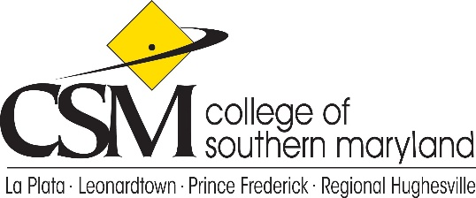

College Planning Council
Agenda Items
March 11, 2021

- Call to Order
- Roll Call
- Approval of the Agenda
- Approval and Review of the December 10, 2020 minutes
- Review of Governance Training Membership Training
  - What questions were answered?
  - What questions remain?
- Review CPC Charter (Cicero)
http://www.hawk.csmd.edu.ezproxy.csmd.edu/governance/participatory.html

- CPC Structure (Parliamentary Procedures) (Lesley)
- Anthology Planning Module (Erin)
- Unfinished Business
- New Business
- Adjournment

Future Meetings: April 8th, May 13th- No June, July, August

April: Recruitment and Enrollment Overview (Tracy Harris)
2021-2024 Institutional Strategic Plan

May: Marketing Overview (Avis McMillin)

EE and PIR support to council
Authority/President’s Council Sponsor: William Comey

