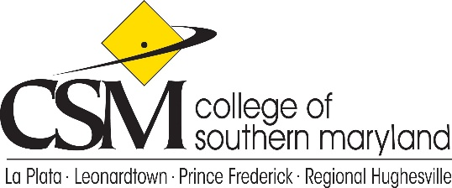

College Planning Council
Agenda
May 13, 2021

- Call to Order
- Approval of the Agenda
- Review and Approval of the April 8, 2021 minutes
- Overview of the OPP Division – Bill Comey
- Mass Email Policy Feedback
- College Wide Council Updates –
  - Constitution and Bylaws
  - Faculty Handbook
- New Business: Telework Policy
- Unfinished Business
- Adjournment

Future Meetings: June 10, 2021

