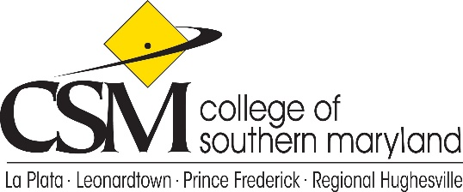

College Planning Council
Agenda
November 11, 2021

- Call to Order
- Review and Approve October 14, 2021 minutes
- Co-Chair Report
- Non-Academic Department Review Process – Joseph Barton, Research Analyst II
- Academic Advising Department Review Process – David Jones, Director Advising, Career, and Transfer Services
- Academic Department Review Process – Cami Cooley, Director, Academic Planning and Assessment
- New Business
- Announcements
- Adjournment

Future Meetings: December 9, 2021, January 13, 2022, February 10, 2022, March 10, 2022, April 14, 2022, May 12, 2022, June 9, 2022

