September 1, 2017
Dr. Raymond Jones, President
Smith Community College
412 Lisner Road
Bowie, Maryland 21411
Dear Dr. Jones:

The Full Block Letter is the college’s chosen letter style. The suggested font and size is Times New Roman, 11 pt.

Type the date at the left margin followed by the inside address. The number of blank lines between the date and the inside address is determined by the letter’s length. Type the salutation a double space below the inside address. If you do not know the name of the person you are writing to, you may address the letter to the desired office or position (i.e. Dear Agent, Committee Member, Customer, Director, Manager, Resident, Teacher; To the President, To the Public Relations Department, To: The Commission on Language Abuse.) If you know the receiver well, use the person’s first name and a colon in the salutation.

Four spaces after the complimentary close type the signature lines, which include the name of the person who wrote the letter and his or her title within the college. The typist’s initials are typed a double space below the signature lines in lower-case letters. If two pages are required to complete the letter, use plain paper for the second page and the same margins as used on the first page. Type a heading including (1) the name of the addressee, (2) the page number, and (3) the date. Before resuming the text, space down three lines from the last line of the heading.

Do not divide the last word on the previous page. Do not divide a paragraph between two pages without including at least two lines of its text on each of the two pages. If the letter is to have an enclosure, the enclosure line is typed a double space below the typist’s initials. Use only initial caps and a colon after the word “enclosure.”

Regards,

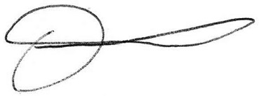
Writers Name
Title, College of Southern Maryland

